Homework 03 - Part II

Zhicheng Zhang (ZZC)

Problem

Create an Oracle RDS Instance

Connect to the Oracle RDS Database Schema to Execute the steps from Part I to create the database schema in your new Oracle RDS instance, connect to the Oracle RDS using the Oracle SQL Developer, create the Oracle database schema using the DDL built for Part I.

Solution

Login to AWS Educate (https://www.awseducate.com/signin/SiteLogin) and go to My Classrooms. Select Database Systems 1.

Click on AWS Console.

On the AWS Console, click on “Services” and in the Group search enter “rds” for Relational Database Services.

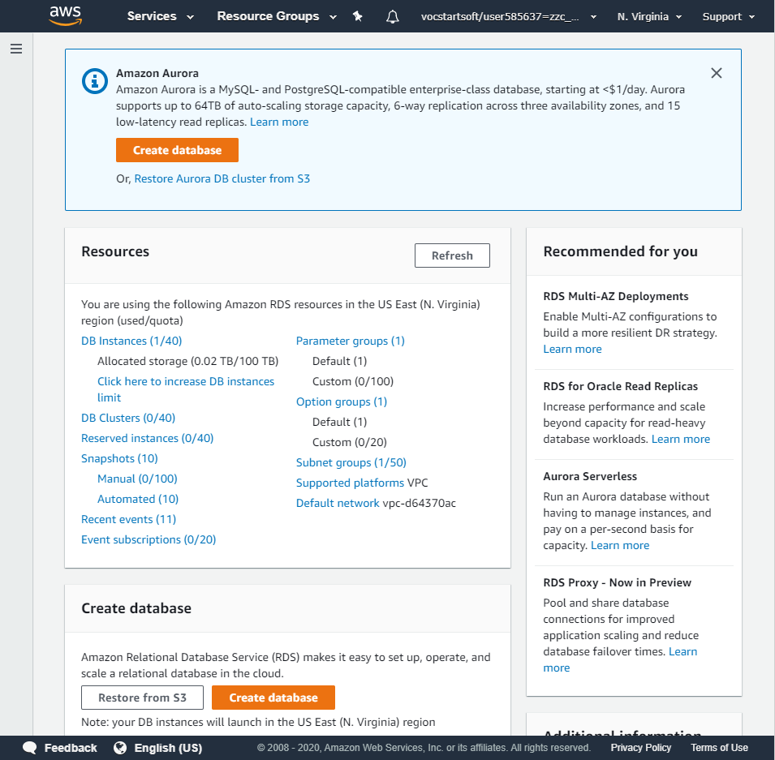

Click on ‘Create Database’.

Select Oracle and Oracle Enterprise Edition.

Choose Dev/Test and click on Next.

For “DB engine version” click on the drop down and select the latest patch level for Oracle 12.2.0.1.

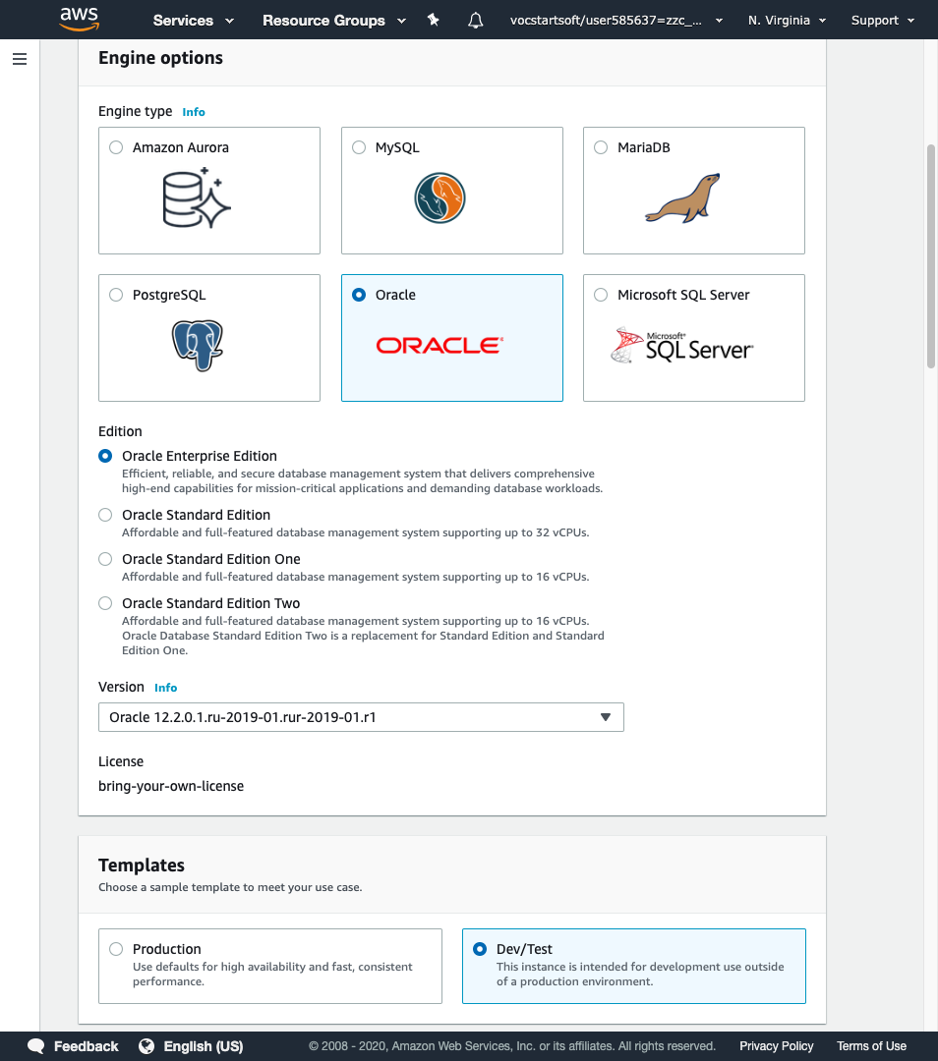

Enter a DB instance name. Example: First letter of first name + First 3 letters of last name + any number

Enter a username and password of your choice.

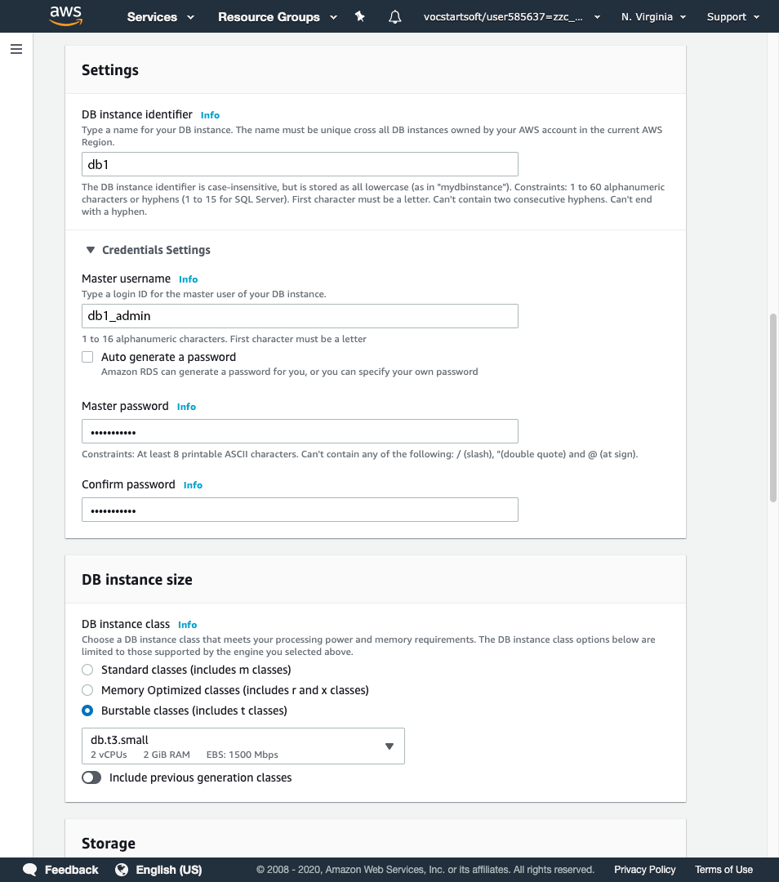

Enable Public accessibility and select availability zone.

Select ‘Create new VPC security group’.

Enter the database name same as your DB instance identifier to make it easier to remember.

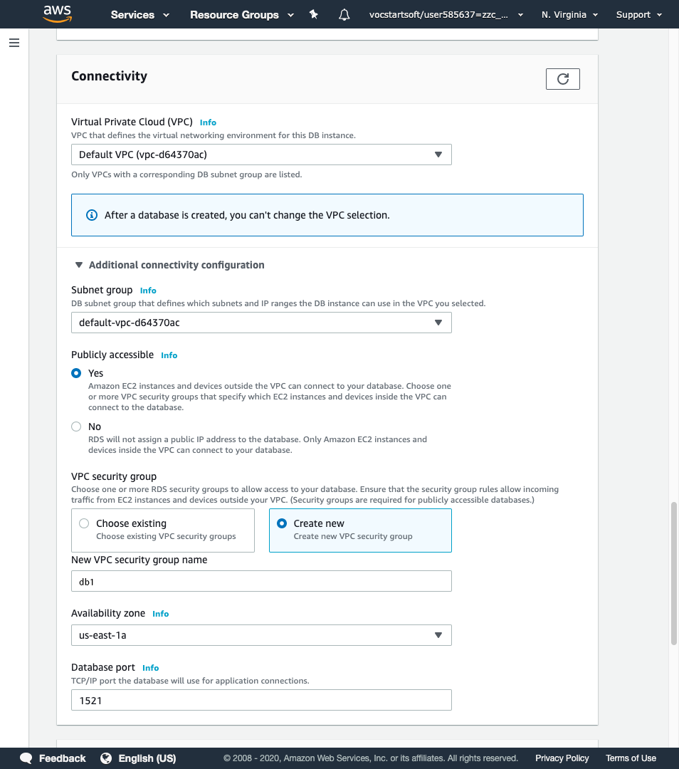

Enter the database name same as your DB instance identifier (step 8) to make it easier to remember.

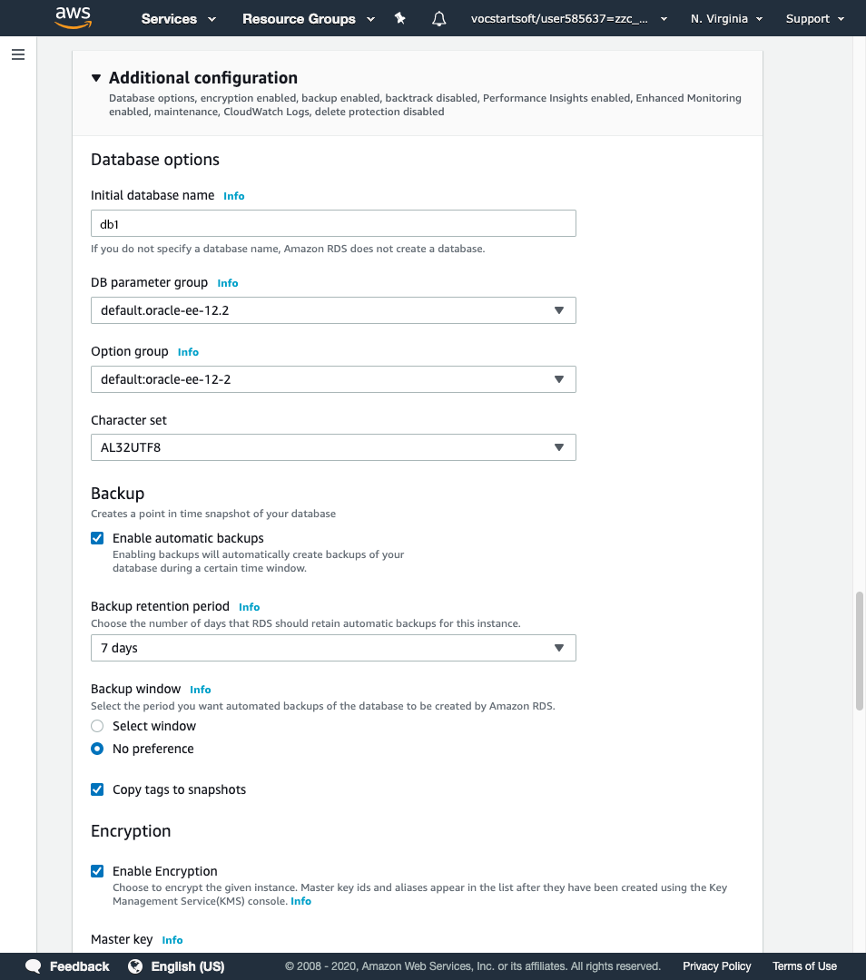

Select ‘Enable enhanced monitoring’ and select all checkboxes under ‘Log exports’.

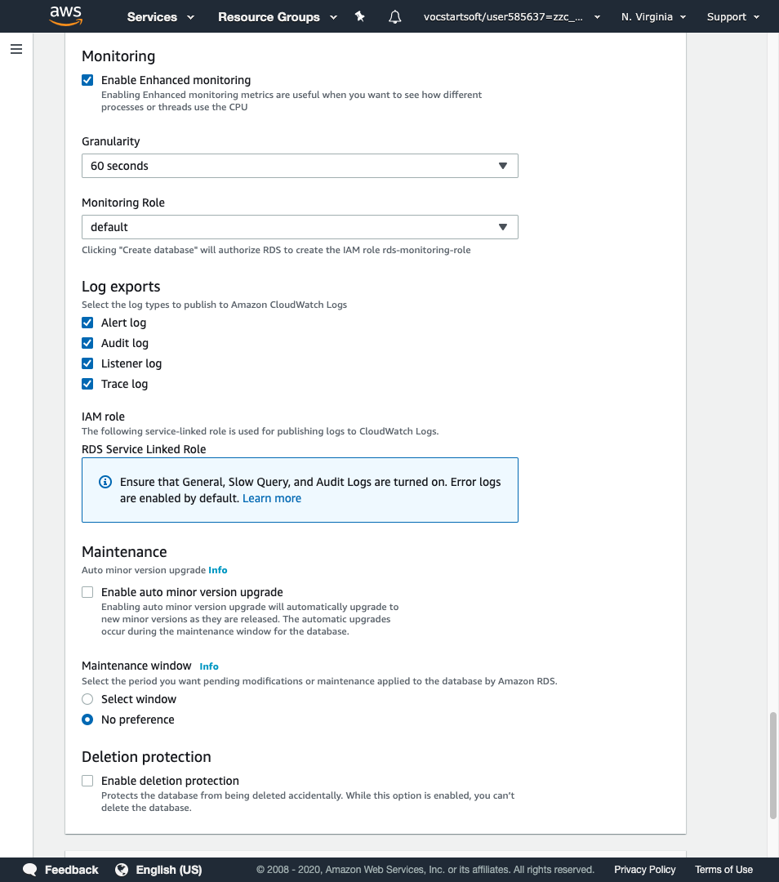

Click on ‘Create Database’.

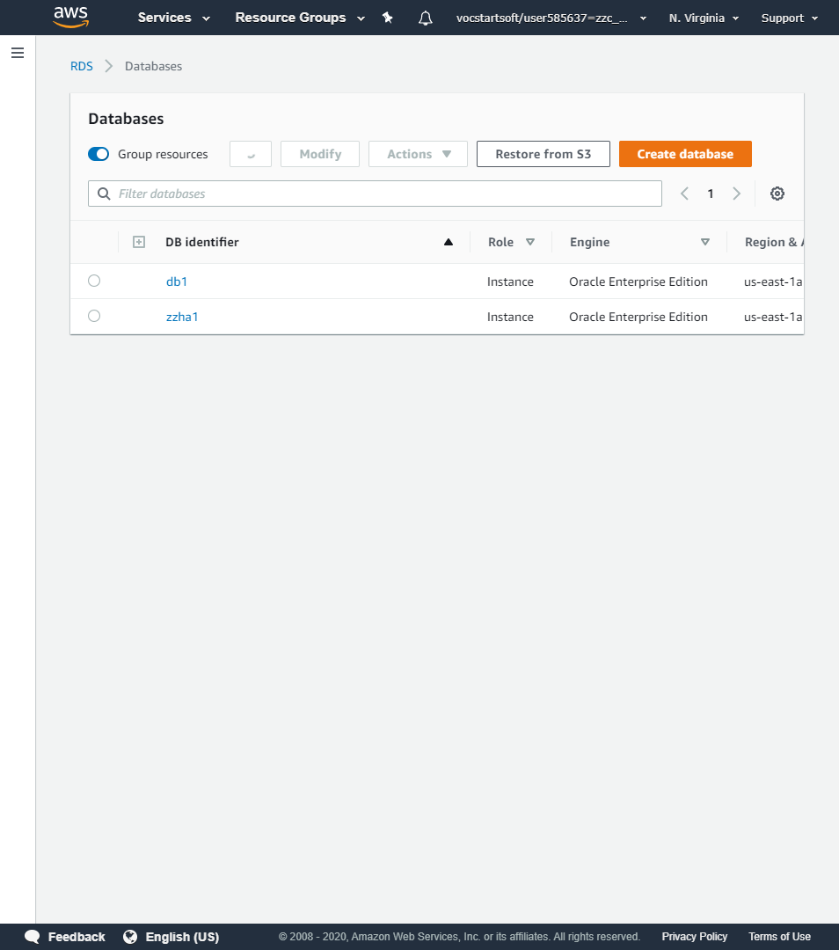

Wait until displays ‘Available’. This may take several minutes.

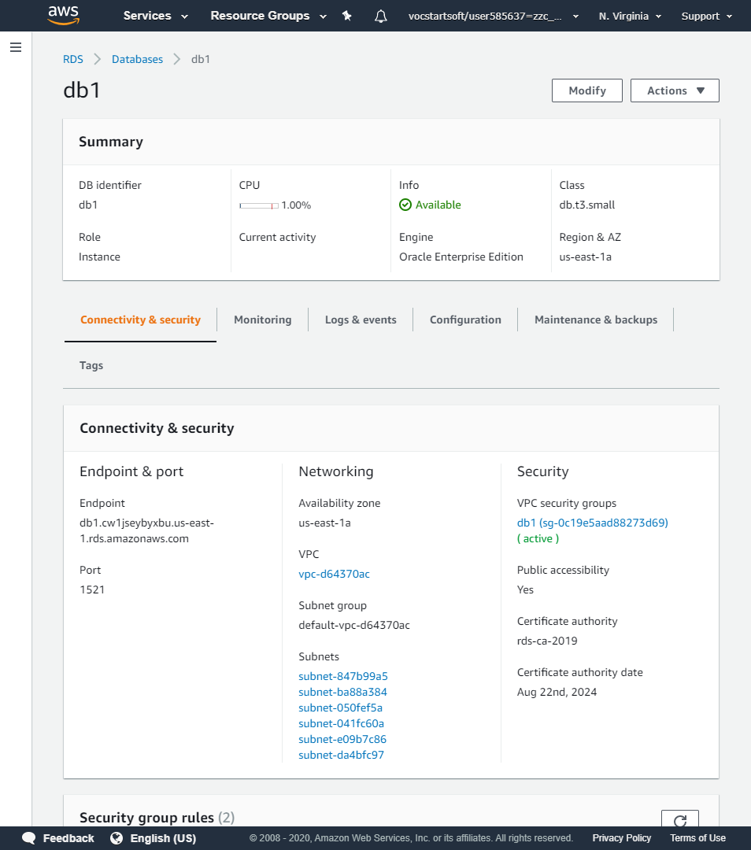

Scroll down to the security section and click on the security group name.

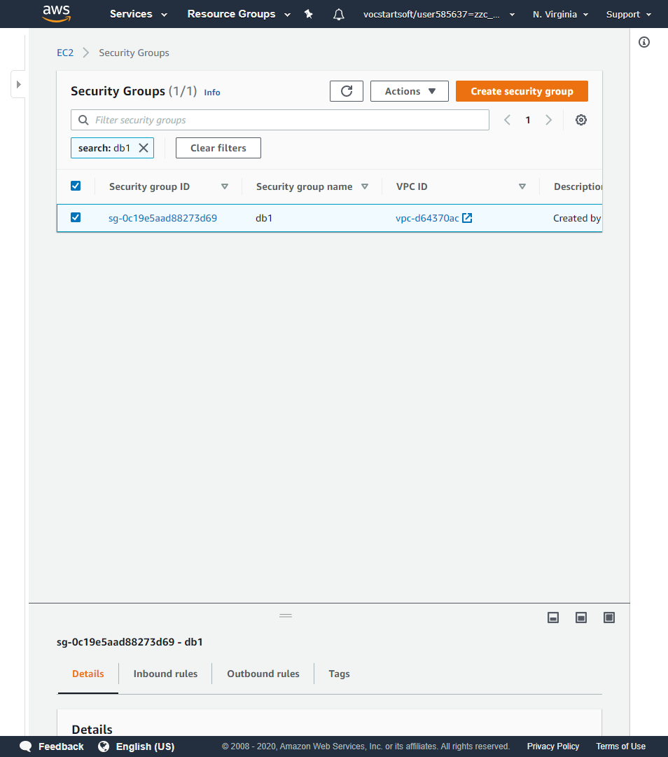

Change on Inbound.

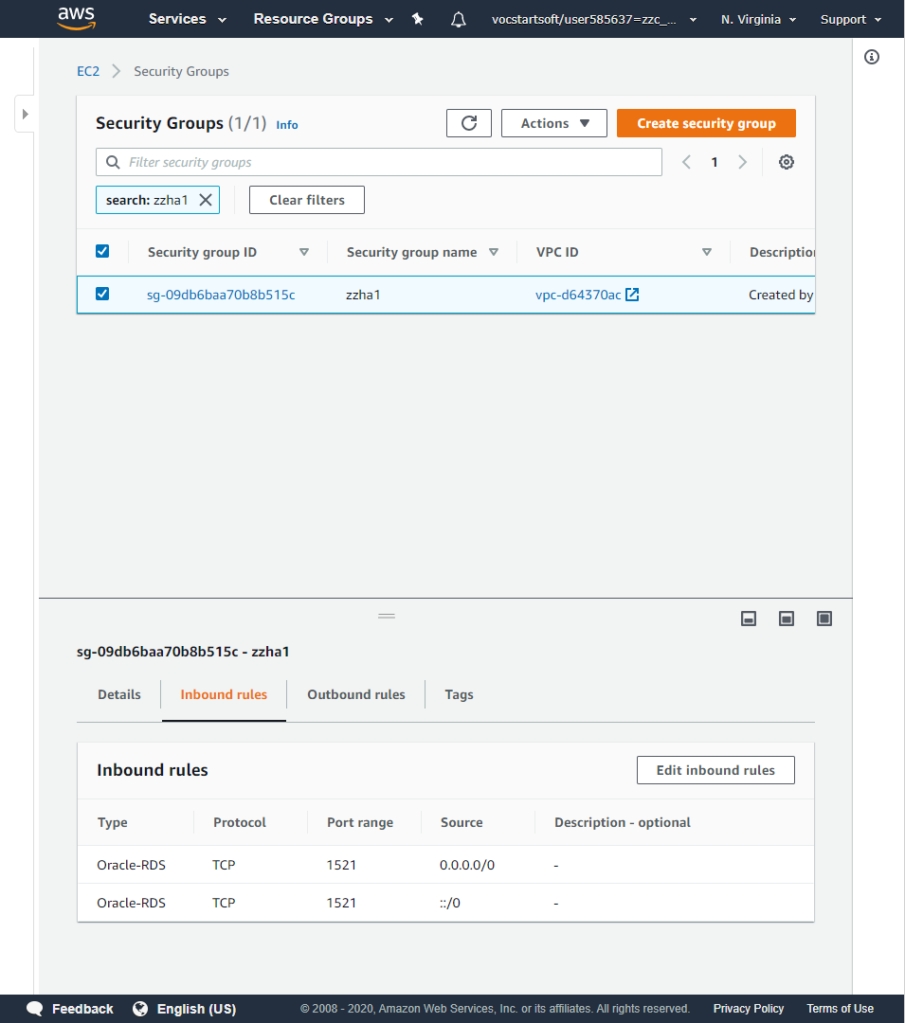

Change on Outbound.

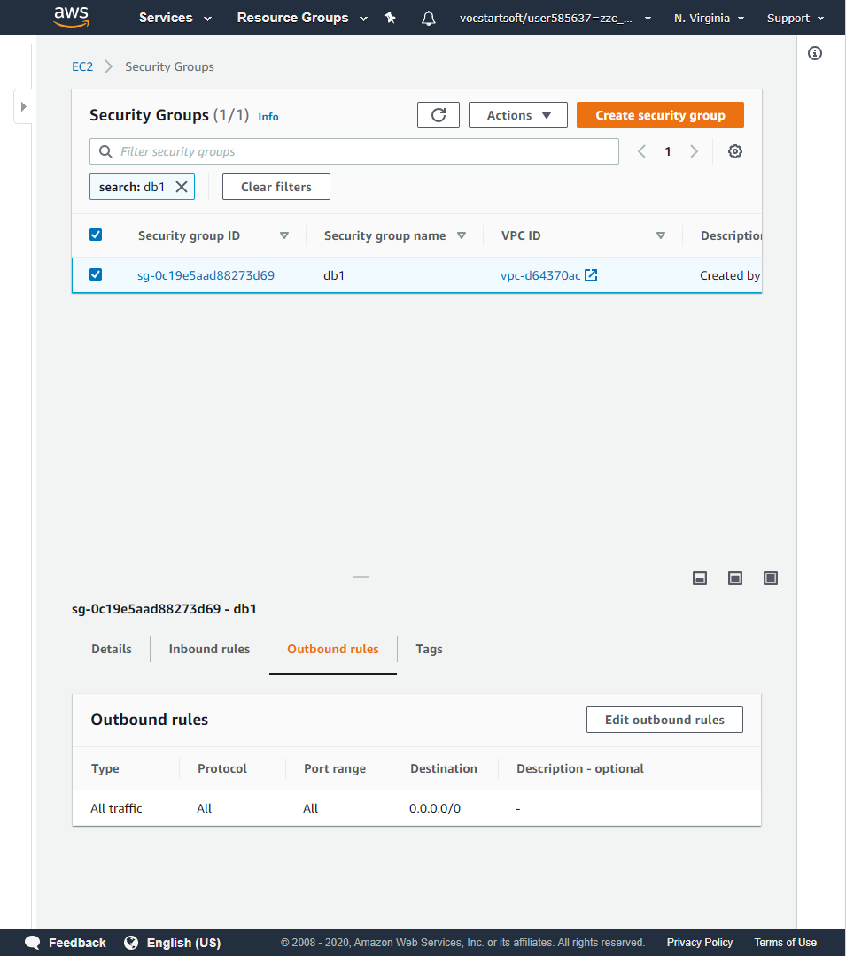

Finish.

